fxMultiTextReplace()

/* fxMultiTextReplace()
An "upgrade" to Power Query's built in Text.Replace() function, which can only
apply one replacement at a time. My function takes two lists, the first containing the texts to look for and the other containing the texts to replace them with.

Must have an equal number of search texts and corresponding replacement texts. If there are more replacement texts than search texts, the excess replacement texts are ignored. If there are more search texts than replacement texts, return "error".

Got the following error when invoking this function on a column of EDI data:
"Expression.Error: We found one or more unbound names when recompiling a function internally. This is almost certainly a bug in our code, one which is triggered when the same symbol name is used in nested scopes. The bug can be avoided by finding the duplicate name and changing one of them. The unbound names were: replace_texts"

N.B. Do **NOT** reuse variable names in enclosing scopes, e.g. I originally used replace_texts in the parameter list of this function, and also in the List.Accumulate() function. Most of the time there's no issue but when I used the Invoke Custom Function button on a column of EDI data, it raised the error mentioned above.

*/

(input_text as text, search_texts as list, replace_texts as list) as any =>
let

//Validations
input_text_ok = Text.Length(input_text) > 0,
search_texts_ok = (List.Count(search_texts) > 0) and not List.ContainsAny(search_texts, {null, ""}),
replace_texts_ok = (List.Count(replace_texts) > 0) and not List.ContainsAny(replace_texts, {null}),
// It's OK if there are more replacements than search texts, but not vice versa
more_searches_than_replacements = if List.Count(search_texts) > List.Count(replace_texts) then true else false,
all_params_ok = (input_text_ok and search_texts_ok and replace_texts_ok) and not more_searches_than_replacements,
new_string = if not all_params_ok then "error"
else
let
// Ignore excess replacements
searches_count = List.Count(search_texts),
replace_texts_trimmed = List.FirstN(replace_texts, searches_count),
updated_text =
List.Accumulate(
{0..searches_count-1},
input_text,
(state, current) =>
let
search_for = search_texts{current},
replace_with = replace_texts_trimmed{current},
update_text = Text.Replace(state, search_for, replace_with)
in
update_text
)
in
updated_text
in
new_string

The Replacements table used in testing:

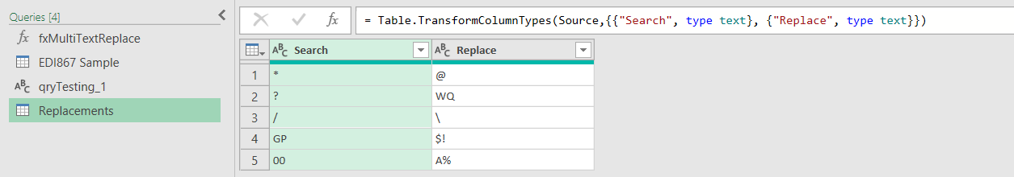

Testing suite:

/* Teating fxMultiTextReplace()
input string: "GS*PT*4405197800*999999999*20110127*1719*1421*X*005010VICS"
Replacements Table:
|Search |Replace
* @
? WQ
/ \
1719 ++LONGER REPLACEMENT STRING++
00 A%
Case 1:
searches: {"*"}
replacements: {"|"}
result: "GS|PT|4405197800|999999999|20110127|1719|1421|X|005010VICS"

Case 2:
searches: {"GS", "44", "2011"}
replacements: {"FX", "$%", "1999"}
result: "FX*PT*$%05197800*999999999*19990127*1719*1421*X*005010VICS"

Case 3:
searches: {"GS", "44", "2011"}
replacements: {"FX", "$%", "1999", "DX^", "123", "@@@", "-!"}
result: "FX*PT*$%05197800*999999999*19990127*1719*1421*X*005010VICS"

Case 4:
searches: Replacements[Search]
replacements: Replacements[Replace]
result: "GS@PT@44051978A%@999999999@20110127@++LONGER REPLACEMENT STRING++@1421@X@A%5010VICS"

Case 5:
searches: {"GS", "44", "2011"}
replacements: {"FX", "$%"}
result: "error"

Case 6:
searches: {"GS", "", "2011"}
replacements: {"FX", "$%", "1999"}
result: "error"

Case 7:
searches: {"GS", "44", null}
replacements: {"FX", "$%", "1999"}
result: "error"

Case 8:
searches: {"GS", "44", "2011"}
replacements: {"", "$%", ""}
result: "*PT*$%05197800*999999999*0127*1719*1421*X*005010VICS"

Case 9:
searches: {}
replacements: {"", "$%", ""}
result: "error"

Case 10:
searches: {}
replacements: {}
result: "error"

Case 11:
searches: {"PT"}
replacements: {null}
result: "error"
*/

let
myText = "GS*PT*4405197800*999999999*20110127*1719*1421*X*005010VICS",
look_for = {},
replace_with = {},
result = fxMultiTextReplace(myText, look_for, replace_with)

in
result

